NOTICE OF ADOPTION

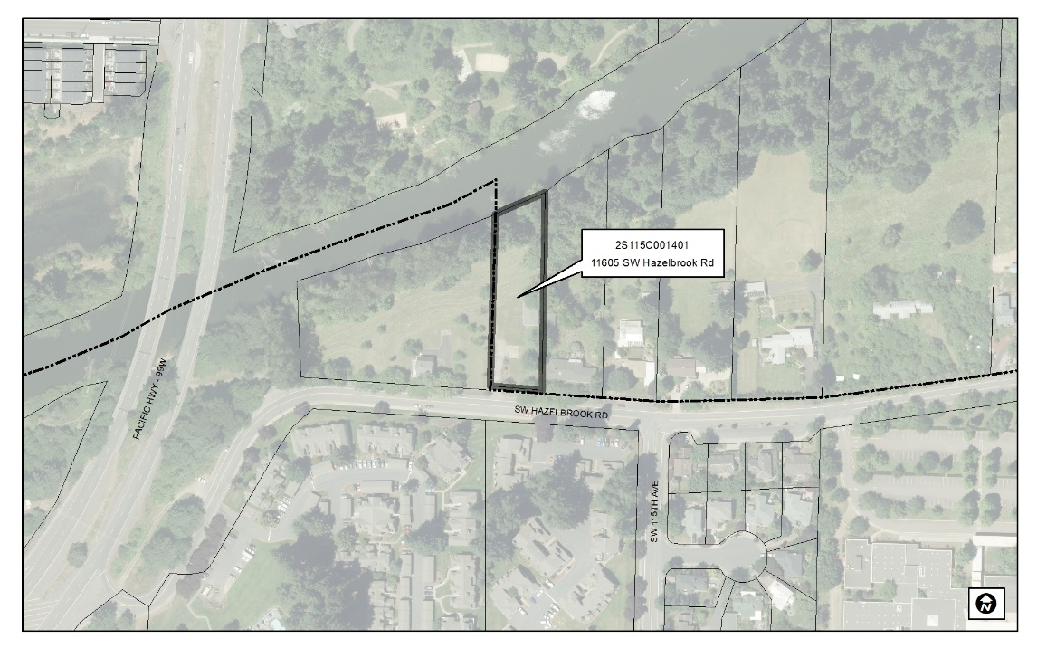
On January 28, 2019 the City of Tualatin adopted Ordinance No. 1416-19, Annexing Territory Located at 11605 SW Hazelbrook Road into the City of Tualatin and Withdrawing the Territory from the Washington County Enhanced Sheriff Patrol District and the County Urban Road Maintenance District. This action approves the Annexation Application for the Hazelbrook Annexation (File No. ANN18-0001) for property located at 11605 SW Hazelbrook Road (Tax Lot 2S115C0001401). A copy of the ordinance is attached.

Appeal of land use decisions is commenced by filing a Notice of Intent to Appeal with the Land Use Board of Appeals as provided in ORS 197.805 - 197.860. The complete case file, and additional copies of the ordinance can be obtained at www.tualatinoregon.gov/projects.
Date notice mailed: January 30, 2019

file: ANN 18-0001

